|  |  |  |
| --- | --- | --- |
| **S.NO** | **TABLE OF CONTENTS** | **PAGE NO.** |
| 1 | **INTRODUCTION** | 1 |
| 2 | **SYNOPSIS** | 2 |
| 3  3.1  3.2  3.2.1  3.2.2 | **SYSTEM CONFIGURATION**  HARDWARE CONFIGURATION  SOFTWARE CONFIGURATION  FRONT END  IMPLEMENTATION | 3  3  3  4  5 |
| 4  4.1  4.2 | **SYSTEM ANALYSIS**  EXISISTING SYSTEM  PROPOSED SYSTEM | 8  8  8 |
| 5  5.1.1  5.1.2  5.2  5.3 | **SYSTEM DESIGN**  CALIBRATION PHASE  RECOGNITION PHASE  INPUT DESIGN  OUTPUT DESIGN | 9  10  12  13  13 |
| 6 | **SYSTEM TESTING AND IMPLEMENTATION** | 14 |
| 7 | **CONCLUSION** | 17 |
| 8 | **SCOPE FOR FUTURE ENHANCEMENT** | 18 |
| 9  9.1  9.2 | **APPENDICES**  SCREENSHOTS  SAMPLE CODING | 19  19 |
| 10 | **BIBILOGRAPHY** | 22 |

# 1.INTRODUCTION

Creating more collaborative and realistic interfaces is one of the most important challenges in human-computer interaction. I am forced to use the device pre-installed on my device. Providing an isolated two-dimensional cursor on a high-resolution pointing system is now essential for computing environments. Modern algorithms provide the best solutions for human-computer interaction every day. In today's world, most mobile phones communicate with users through touchscreen technology.

However, the technology is still very expensive for use on desktops and laptops. Since then, technology has advanced so much that a wireless mouse was introduced, which made mouse movements smoother and more accurate. This project is for developing a virtual mouse with hand gesture recognition. Hand gestures are the most effortless and natural way of communicating. The goal is to perform various cursor manipulations. Instead of using more expensive sensors, a simple webcam can recognize gestures and perform actions.

Helps the user interact with the computer without using a physical or hardware device to control mouse. The AI Virtual mouse program is developed using the Python programming language and of the OpenCV computer library. The proposed AI visual mouse system model uses the Media Pipe package to track hands and the PyAutoGUI packages to navigate the computer screen, left-click, right-click. Perform tasks such as scrolling. The results of the proposed model show a very high level of accuracy, and the proposed model performs very well in real-world applications, even when using CPU instead of GPU.

**1**

## 2. SYNOPSIS

The PC mouse is one of mankind’s most amazing developments in the field of Human Computer Interaction innovation. In the modern era of innovation, remote mouse or a contact less mouse utilizes gadgets, since it utilizes power from gadgets or might be outside power sources like battery, gain space and electric power. Virtual mouse implemented with hand gesture tracking based on the image is one of the studies in human-computer interaction.

It is utilizing hand signal framework, this constraint might be resolved by involving advanced camera or sacred camera for perceive the hand motions and finger recognition. It shows that we can control our screen by moving our fingers which will work as cursor. To make this happen, all we need a working web camera and three main packages that are Mediapipe, OpenCV and the last package is pyautoGUI. Mediapipe is employed for hand tracking, OpenCV for image processing and drawing and the pyautoGUI for controlling the mouse movements and its functioning.

The use of virtual Mouse is that it provides an infrastructure between the user and the system using only a camera. It allows users to interface with machines without the use of mechanical or physical devices, and even control mouse functions. This project shows that how to build this mouse control system.

**2**

**3.SYSTEM CONFIGURATION**

**3.1. HARDWARE CONFIGURATION**

### COMPONANTS REQUIREMENTS

PROCESSOR : Intel(R) Core(TM) i3

RAM : 4.00GB

SYSTEM TYPE : 64-bit operating system

WEBCAM : 720p HD Webcam

**3.2.SOFTWARE CONFIGURATION**

### COMPONANTS REQUIREMENTS

OPERATING SYSTEM : WINDOWS 10

LANGUAGE : PYTHON

TOOL KIT : IMAGE PROCESSING

IDE : PYCHARM

**3**

#### 3.2.1 FRONT END

##### 3.2.1.1

**PYTHON:**

**Python** is a [high-level,](https://en.wikipedia.org/wiki/High-level_programming_language) [general-purpose programming language.](https://en.wikipedia.org/wiki/General-purpose_programming_language) Its design philosophy emphasizes [code readability](https://en.wikipedia.org/wiki/Code_readability) with the use of significant indentation via the [off-side rule.](https://en.wikipedia.org/wiki/Off-side_rule)

Python is [dynamically typed](https://en.wikipedia.org/wiki/Type_system#DYNAMIC) and [garbage-collected.](https://en.wikipedia.org/wiki/Garbage_collection_(computer_science)) It supports multiple [programming paradigms,](https://en.wikipedia.org/wiki/Programming_paradigm) including [structured](https://en.wikipedia.org/wiki/Structured_programming) (particularly [procedural)](https://en.wikipedia.org/wiki/Procedural_programming), [object-oriented](https://en.wikipedia.org/wiki/Object-oriented_programming) and [functional programming.](https://en.wikipedia.org/wiki/Functional_programming) It is often described as a "batteries included" language due to its comprehensive [standard library.](https://en.wikipedia.org/wiki/Standard_library)

[Guido van Rossum](https://en.wikipedia.org/wiki/Guido_van_Rossum) began working on Python in the late 1980s as a successor to the [ABC programming language](https://en.wikipedia.org/wiki/ABC_(programming_language)) and first released it in 1991 as Python 0.9.0. Python 2.0 was released in 2000. Python 3.0, released in 2008, was a major revision not completely [backwardcompatible](https://en.wikipedia.org/wiki/Backward_compatibility) with earlier versions. Python 2.7.18, released in 2020, was the last release of Python 2.

Python consistently ranks as one of the most popular programming languages.

Python is a [multi-](https://en.wikipedia.org/wiki/Multi-paradigm_programming_language)paradigm programming languag[e.](https://en.wikipedia.org/wiki/Multi-paradigm_programming_language) [Object-oriented programming](https://en.wikipedia.org/wiki/Object-oriented_programming) and [structured programming](https://en.wikipedia.org/wiki/Structured_programming) are fully supported, and many of their features support functional programming and [aspect-oriented programming](https://en.wikipedia.org/wiki/Aspect-oriented_programming) (including [metaprogramming](https://en.wikipedia.org/wiki/Metaprogramming) and [metaobjects)](https://en.wikipedia.org/wiki/Metaobject). Many other paradigms are supported via extensions, including [design by contract](https://en.wikipedia.org/wiki/Design_by_contract) and [logic programming.](https://en.wikipedia.org/wiki/Logic_programming)

Python uses [dynamic typing](https://en.wikipedia.org/wiki/Dynamic_typing) and a combination of [reference counting](https://en.wikipedia.org/wiki/Reference_counting) and a cycledetecting garbage collector for [memory management.](https://en.wikipedia.org/wiki/Memory_management) It uses dynamic [name resolution](https://en.wikipedia.org/wiki/Name_resolution_(programming_languages)) [(late binding)](https://en.wikipedia.org/wiki/Late_binding), which binds method and variable names during program execution.

Its design offers some support for functional programming in the [Lisp](https://en.wikipedia.org/wiki/Lisp_(programming_language)) tradition. It

|  |  |  |  |  |
| --- | --- | --- | --- | --- |
| filter | , | map | and | reduce |

has functions; [listcomprehensions,](https://en.wikipedia.org/wiki/List_comprehension) [dictionaries,](https://en.wikipedia.org/wiki/Associative_array)sets, and [generator](https://en.wikipedia.org/wiki/Generator_(computer_programming)) expressions..

**4**

**3.2.2.IMPELMENTATION:**

Open PyCharm and go to settings after that choose the python interpreter. Install the required packages. OpenCV, Mediapipe, pyautoGUI. Python is used as base language because it is simple an open source and simple to grasp and environment friendly. By using these packages, we can programmatically control the actions of the mouse.

#### 3.2.2.1)OPENCV

OpenCV is the great tool for image processing and performing the computer visiontasks. It is used for open the webcam and declare the frame size. OpenCV means Open source Computer Vision library is a programming function written in C++ mainly aimed at computer vision. It was licensed by Apache and introduced by Intel. This library is cross platform and free to use and it provides a feature of Gpu acceleration for real time operations. OpenCv are used in wide areas like as 2D & 3D feature toolkit and in mobile robotics.

#### 3.2.2.2)MEDIAPIPE

It is a cross platform framework that’s mostly used for building multimedia pipelinemachine learning, and it’s an open-source framework by Google. Mediapipe frameworkworks as multimodal, which implies this framework is applied to face detection, facemask, pose detection, object detection, motion tracking. This is concept of virtual mouse the mediapipe library is mainly used for hand detection. It detects the hands by using Hands () method. Drawing_utils is used to detect the landmarks in the hand.

**5**

rgb_frame=cv2.cvtColor(frame,cv2.COLOR_BGR2RGB)

output=hand_detector.process(rgb_frame) hands=output.multi_hand_landmarks

drawing_utils.draw_landmarks(frame,hand)

landmarks=hand.landmark cv2.COLOR_BGR2RGB is used to convert the image in the RGB format and it gives the

output of the image with hand landmarks. Hand landmark means edges or points in the

hand.

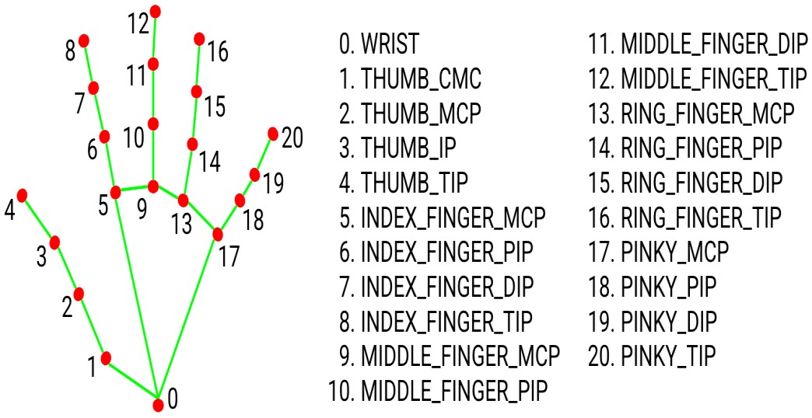

**FIGURE 1 – IMPRESSIONS OF THE HAND**

#### 3.2.2.3)PYAUTOGUI

Python Pyautogui library is an automation library that allows that allows mouse and keyboard control. PyautoGUI is a cross-platform GUI automation python module for humanbeings. We can move the mouse and click in the other application’s window. It allows us tolocate a window of the application and move, maximize, minimize, resize, or close it. It is used to find the screen width and height.

**6**

screen_width, screen_height =pyautogui.size() size() method returns the size of the primary monitor.

pyautogui.moveTo(index_x,index_y)

One of the method in pyautogui is moveTo () and it moves the mouse to the XY coordinate.It takes the three parameters - X, Y coordinates, and duration. The cursor moves to thementioned coordinates according to the given time duration when running the above function. The duration is time in seconds.Passed the ten seconds means the cursor will take ten seconds to locate the coordinates.

pyautogui.click()

pyautogui.sleep(1)

click() method used for first moves the cursor to the defined coordinate and click as per

given the number of clicks. Sleep() method is used to sleep the program for 1 second.

**7**

## 4. SYSTEM ANALYSIS

1. **1.EXISTING SYSTEM :**

The existing system required very high costs and resources. Because of this, there weren't many users who could afford it. There are a lot of software and applications on the Internet that claim to control the mouse without touching it**,** but instead of controlling the mouse virtually with coloured tape fingers or using color monitoring. to, as they say, does not check reality. A technique that no one is suited to manage such things.

**4.2. PROPOSED SYSTEM :**

The proposed method can capture important images and videos from a webcam, through which the videos can be converted to images for processing. The converted image consists of different fingertips that we will extract from the photo in the next step. Once the extraction process is complete, points are recognized based on the given ID of the corresponding fingertip. This process is called recognition mode and point recognition. After detecting the point, it tracks the movement of the pointer as it moves across the screen. Then you can perform mouse actions.

**8**

# 5.SYSTEM DESIGN

During the process of colour recognition, it contains 2 major phases which are the calibration phase and recognition phase. The purpose of the calibration phase is to allow the system to recognize the Hue Saturation Values of the colours chosen by the users, where it will store the values and settings into text documents, which will be used later on during the recognition phase. While on the recognition phase, the system will start to capture frames and search for colour input with based on the values that are recorded during the calibration phase. The phases of the virtual mouse is as shown in figure below.

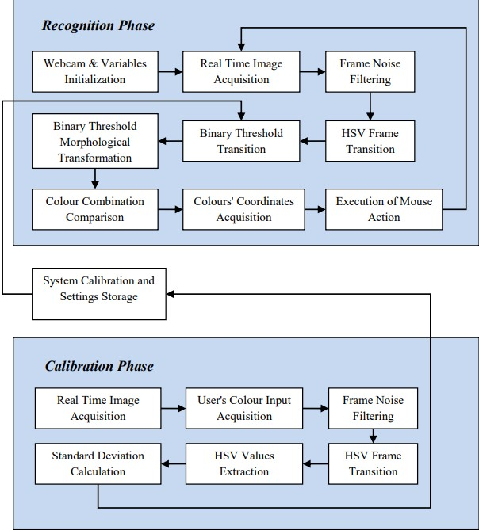

**FIGURE 2 – ARCHITECTURE OF VIRTUAL MOUSE**

**9**

**5.1.1 Calibration Phase:**

1. **Real Time Image Acquisition:**

The program will start of by capturing real-time images via a webcam where it will awaitfor users' colour input. The size of the acquired image will be compressed to a reasonablesize to reduce the processing loads of processing the pixels within the captured frame.

1. **User's Colour Input Acquisition:**

The program acquires the frames that consist of input colours submitted by the users, the captured frame will be sent for process where it will undergone a series of transition and calculation to acquire the calibrated HSV values.

1. **Frame Noise Filtering:**

Every captured frame consists of noises that will affect the performance and the accuracy of the program, therefore the frame require to be noise free. To do that, filters need to be applied on the captured frames to cancel out the unwanted noise. For the current project, Gaussian filter will be used, which is a common smoothing method to eliminate noise in a frame. This can be done by using GaussianBlur(InputArray src, OutputArray dst, Size ksize, double sigmaX, double sigmaY=0, intborderType = BORDER_DEFAULT ).

1. **HSV Frame Transition:**

The captured frame require to be converted from a BGR format to a HSV format. Which can be done by using cvtColor(src, dst, CV_BGR2HSV).

1. **HSV Values Extraction**:

In order to acquire the HSV values, the converted frame require to be split into 3 single different planes, to do that the frame needs to be divided from a multi-channel array into a single channel array, which can be done by using split(const Mat& src, Mat* mvbegin).

## 10

**f) Standard Deviation Calculation:**

To obtain the maximum and the minimum of the HSV values, it requires to gone through the Standard Deviation calculation, a measurement used to quantify the amount of variation / dispersion among other HSV values. Furthermore, to obtain an accurate range of values, three-sigma rule are required in the calculation, so that chances of the captured values have a very high possibility to fall within the three-sigma intervals.

**5.1.2. Recognition Phase:**

1. **Webcam & Variables Initialization:**

On the early stage of the recognition phase, the program will initialize the required variables which will be used to hold different types of frames and values where each are will be used to carry out certain task. Furthermore, this is the part where the program collects the calibrated HSV values and settings where it will be used later during the transitions of Binary Threshold.

1. **Real Time Image Acquisition:**

The real time image is captured by using the webcam by using (cv::VideoCapture cap(0);), where every image captured are stored into a frame variable (cv::Mat), which will be flipped and compressed to a reasonable size to reduce process load.

1. **Frame Noise Filtering:**

Similar to the noise filtering during the calibration phase, Gaussian filters will be applied to reduce the existing noise of the captured frames. This can be done by using GaussianBlur(InputArray src, OutputArray dst, Size ksize, double sigmaX, double sigmaY=0, intborderType=BORDER_DEFAULT ).

## 11

1. **HSV Frame Transition:**

The captured frame require to be converted from a BGR format to a HSV format. Which can be done by using cvtColor(src, dst, CV_BGR2HSV).

1. **Binary Threshold Transition:**

The converted HSV frame will undergone a range check to check if the HSV values of the converted frame lies between the values of the HSV variables gathered during the calibration phase. The result of the range check will convert the frame into a Binary Threshold, where a part of the frame will set to 255 (1 bit) if the said frame lies within the specified HSV values, the frame will set to 0 ( 0 bit) if otherwise.

1. **Binary Threshold Morphologica:**

l Transformation After the binary threshold is obtained, the frame will undergone a process called Morphological Transformation, which is a structuring operation to eliminate any holes and small object lurking around the foreground. The transformation consist of two morphological operators, known as Erosion and Dilation. The Erosion operator are responsible for eroding the boundaries of the foreground object, decreasing the region of the binary threshold, which is useful for removing small noises. As for Dilation, it is an opposite of erosion, it increases the region of the binary threshold, allowing eroded object to return to its original form. For the current project, both operators were used for morphological Opening and Closing.

## 12

### 5.2 INPUT DESIGN

Input design is the process of converting the user-oriented. Input to a computer based format. The goal of the input design is to make the data entry easier, logical and free error. Errors in the input data are controlled by the input design. The quality of the input determines the quality of the system output.

The entire data entry screen is interactive in nature, so that the user can directly enter into data according to the prompted messages. The users are also can directly enter into data according to the prompted messages. The users are also provided with option of selecting an appropriate input from a list of values. This will reduce the number of error, which are otherwise likely to arise if they were to be entered by the user itself.

### 5.3 OUTPUT DESIGN

Output design is very important concept in the computerized system, without reliable output the user may feel the entire system is unnecessary and avoids using it. The proper output design is important in any system and facilitates effective decisionmaking. The output design of this system includes various reports.

Computer output is the most important and direct source of information the user. Efficient, intelligible output design should improve the system’s relationships with the user and help in decision making. A major form of output is the hardcopy from the printer.

**13**

# 6.SYSTEM TESTING AND IMPLEMENTATION

## 6.1 SYSTEM TESTING

Web Application testing is a crucial element of applications quality assurance and represents the unlimited review of specification, design and coding. Testing represents an interesting anomaly for the software.

The testing phase is responsible for ensuring that the system performs the way that the detailed design documentation specifies. Testing involves testing of developed system using various test data. Preparation of test data plays a vital role in system testing. After preparing the test data, the system under study was tested using those test data. During this stage, the errors are detected and corrected.

Testing is vital to the parts of the system are correct; the goal will be successfully achieved. Inadequate testing or non-testing leads to errors that may not appear until this months later.

This creates two problems:

* This time lag between the cause and appearance of the problem.
* The effort of system errors on files and records within the system. A small system error can conceivably exploded into much larger problem. Effectively early in the process translates directly into long term cost savings from a reduced number of errors.

## 6.1.1)UNIT TESTING

Unit tests perform basic test at component level and test a specific business process, application, and /or system configuration. Unit tests ensure that each path of a business process performs accurately to the documented specifications, functionality and contains clearly defined inputs and expected results.

## 14

### 6.1.2)VALIDATION TESTING

Validation succeeds when the developed system functions as per the requirement of the customer. Application validation is achieved through a series of black box that demonstrate the conformity with the requirements. Deviations or errors in this steps are corrected.

### 6.1.3)OUTPUT TESTING

Various outputs has been generated by the system. The system generated output and the desk-calculated values have been compared. All the output is perfect as the company desires. It begins with the low volumes of transactions based on live tone. The volume is increased until the maximum level for each transaction type is reached. The total system is also tested for recovery and fall back, after various major failures to ensure that no data are lost during the emergency time.

### 6.1.4) INTEGRATION TESTING

Integration tests are done to test integrated application components were individually satisfactory, as shown by successful unit testing; the combination of components is correct and consistent

## 15

### 6.2.SYSTEM IMPLEMENTATION

It is the stage of implementation, which ensures that system works accurately and effectively before the live operation commences. It is a confirmation that all are correct and opportunity to show the users that the system must be tested with the text data and show that the system will operate successfully and produce expected results under expected conditions.

Before implementation, the proposed system must be tested with raw data to ensure that the modules of the system work correctly and satisfactorily. The system must be tested with valid data to achieve its objective.

System implementation is the stage of the project when the theoretical design is turned into a working system. If the implementation stage is not correctly planned and controlled, it can be choice. The following are the main stages in the implementation:

* Planning
* Training
* Maintenance

### 6.2.1)PLANNING

Planning plays an important role in the implementation. The planning should face any practical problems of controlling various activities of people out their own data processing department.

### 6.2.2)TRAINING

Successful implementation needs trained computer staff. So some staff can teach them about the computer implementation, which only then becomes a welldesigned system.

### 6.2.3)MAINTENANCE

Maintenance involves recovery on crash such as the backups and the end user should be given only executable format of the system.

**16**

## 7. CONCLUSION

Motion acknowledgment method gives the positive indications for performing different mouse functions. Virtual mouse is an idea of implementing an adaptable, multimedia functional navigation or interaction tool that overcomes physical barriers. It enables the web camera which recognizes fingers and hand gestures and it process the captured frame. It uses a machine learning algorithm to execute the defined mouse functions. After testing I have come to the conclusion that the proposed virtual mouse system has worked exceedingly well and with great accuracy when compared to previously proposed models and the current system has overcome the drawbacks of the other system. This system will be improved in the future for right click, left click etc... Without using any external devices and sensors it uses the real time hand motions.

**17**

## 8. SCOPE FOR FUTURE ENHANCEMENT

* Virtual mouse has some drawbacks much as drop in accuracy of some functions like right click operation and inability to perform other mouse functions such as dragging, dropping and selecting text.
* Another major limitation is that this model cannot function in the dark or low light settings. These drawbacks can be addressed in the future and it can be overcome.
* Furthermore, the proposed method can be developed to handle not only the mouse along with keyboard

**18**

**9.APPENDICES**

# 9.1 SCREENSHOTS

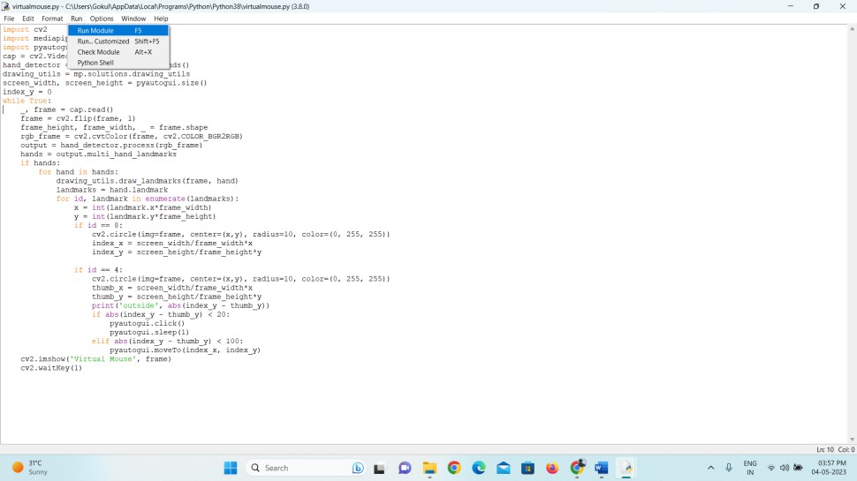

## FIGURE 3 – RUNNING THE CODE OF VIRTUAL MOUSE

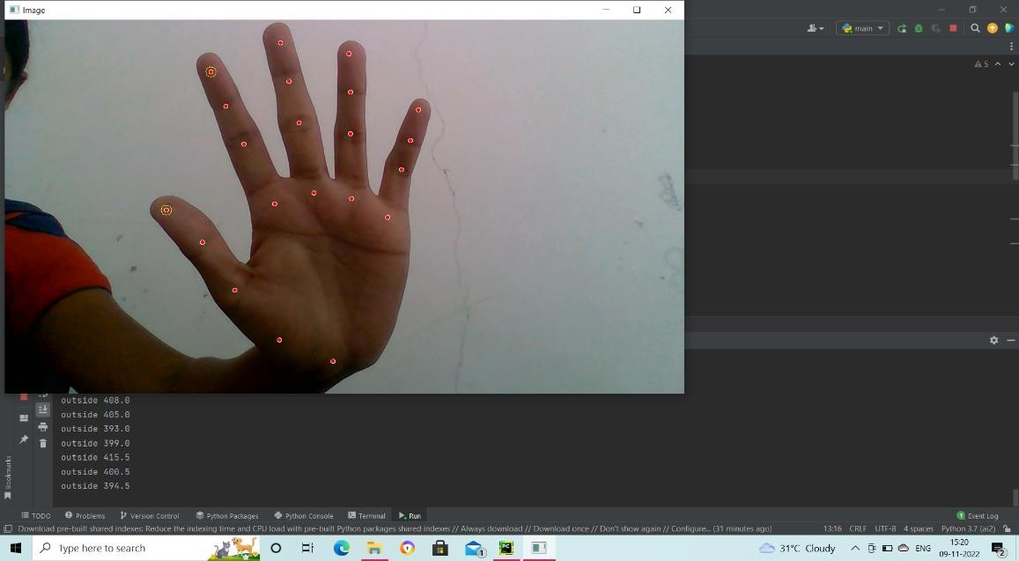

**FIGURE 4- NEUTRAL IMAGE AND CURSOR MOVEMENT**

## 19

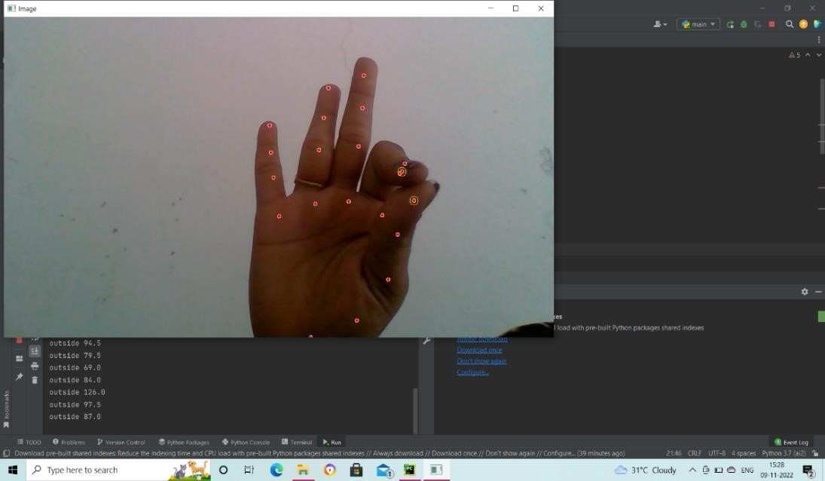

### FIGURE 5- CLICKING THE TAB ON THE WINDOW

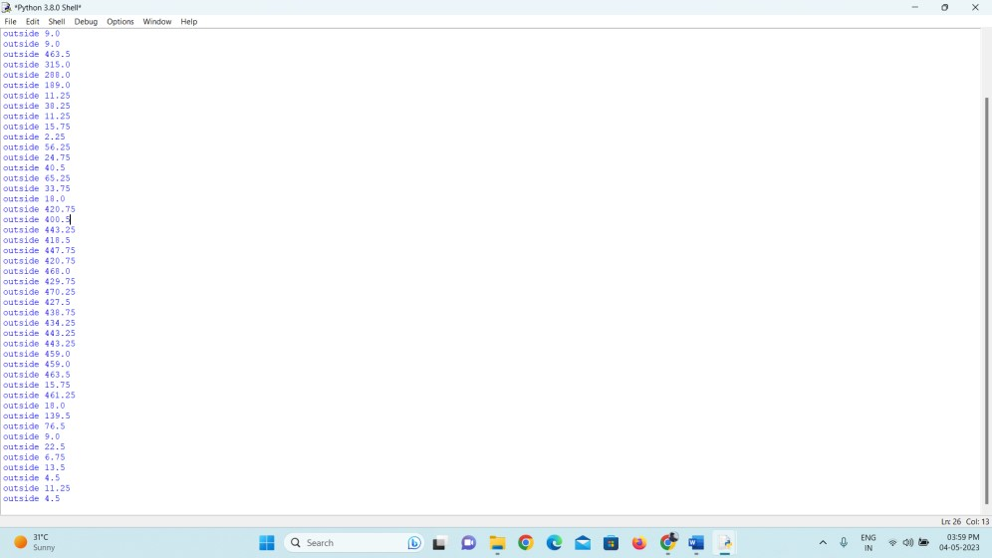

**FIGURE 6 – RATIO PAGE OF THE CURSOR**

**19**

# 9.2 SAMPLE CODES

import cv2 import mediapipe as mp import pyautogui cap = cv2.VideoCapture(0) hand_detector = mp.solutions.hands.Hands() drawing_utils = mp.solutions.drawing_utils screen_width, screen_height = pyautogui.size() index_y = 0 while True:

_, frame = cap.read() frame = cv2.flip(frame, 1) frame_height, frame_width, _ = frame.shape rgb_frame = cv2.cvtColor(frame, cv2.COLOR_BGR2RGB) output = hand_detector.process(rgb_frame) hands = output.multi_hand_landmarks if hands: for hand in hands:

drawing_utils.draw_landmarks(frame, hand) landmarks = hand.landmark for id, landmark in enumerate(landmarks):

x = int(landmark.x*frame_width) y = int(landmark.y*frame_height) if id == 8:

cv2.circle(img=frame, center=(x,y), radius=10, color=(0, 255, 255)) index_x = screen_width/frame_width*x index_y = screen_height/frame_height*y

## 20

if id == 4:

cv2.circle(img=frame, center=(x,y), radius=10, color=(0, 255, 255)) thumb_x = screen_width/frame_width*x thumb_y = screen_height/frame_height*y print(‘outside’, abs(index_y – thumb_y)) if abs(index_y – thumb_y) < 20:

pyautogui.click() pyautogui.sleep(1) elif abs(index_y – thumb_y) < 100:

pyautogui.moveTo(index_x, index_y) cv2.imshow(‘Virtual Mouse’, frame) cv2.waitKey(1)

**21**

# 10.BIBILOGRAPHY

## REFERENCE BOOKS

1. S. U. Dudhane, “Cursor control system using hand gesture recognition,” IJARCCE, vol. 2, no. 5, 2013.
2. A. Haria, A. Subramanian, N. Asokkumar, S. Poddar, and J. S. Nayak, “Hand gesture recognition for human computer interaction,” Procedia Computer Science, vol. 115, pp. 367– 374, 2017.
3. K. H. Shibly, S. Kumar Dey, M. A. Islam, and S. Iftekhar Showrav, “Design and development of hand gesture based virtual mouse,” in Proceedings of the 2019 1st International Conference on Advances in Science, Engineering and Robotics Technology (ICASERT), pp. 1–5, Dhaka, Bangladesh, May 2019.

## WEBSITES

1. [https://ieeexplore.ieee.org](https://ieeexplore.ieee.org/)
2. <https://github.com/ProgrammingHero1/virtual_mouse>
3. <https://google.github.io/mediapipe/solutions/hands.html>
4. <https://www.javatpoint.com/opencv>

## 22